**DOA ESTIMATION FOR WIDEBAND LFM SIGNALS**

**WITH A FEW SNAPSHOTS**

**CHAPTER -1**

**ABSTRACT**

The wideband linear frequency modulation (LFM) signals are widely used in information systems. The conventional direction-of arrival (DOA) estimation algorithms of LFM signals rely on a large number of snapshots, some of which are not reliable in numerous practical applications such as underwater array processing. To solve the above problem, we present a modified sparse iterative covariance (MSPICE)-based estimation method in fractional Fourier transform (FrFT) domain to estimate the DOA of wideband LFM signals. First, we extend the original SPICE algorithm in FrFT domain with a specific transform order for wideband LFM signals. Then, we utilize the energy centrobaric modification method to make the original SPICE more accurate without adding more computational complexity. The simulation results demonstrate the effectiveness of the proposed method.

Keywords: Direction of arrival, Fractional Fourier transform, Iterative approach, Wideband LFM.

**CHAPTER-2**

**INTRODUCTION**

Radar is an acronym for Radio Detection and Ranging. It is an electromagnetic system used for detecting and locating objects by transmitting the signals and receiving the transmitted signals from the objects within its range. The echoes received are used to extract information about the target such as range, angular position, velocity and other characteristics. The reflected energy that is returned to the radar not only indicates the presence of a target, but by comparing the received echo signal with the transmitted signal, various information can be extracted regarding the target[4].

The basic principle of radar is shown is Figure 1.1. A transmitter generates a signal (a short pulse or sine wave) that is radiated into the space through a antenna. A part of the transmitted signal is intercepted by the target object and is reflected back in many directions. The reflected signal is collected by the antenna of the radar which inputs it to a receiver. Processing occurs to detect the presence of the target and to determine its location. A single antenna is generally used on a timeshared basis for both transmitting and receiving where the radar signal is a continuous series of pulses. Range can be measured by calculating the time the signal takes to travel to the target and return back.

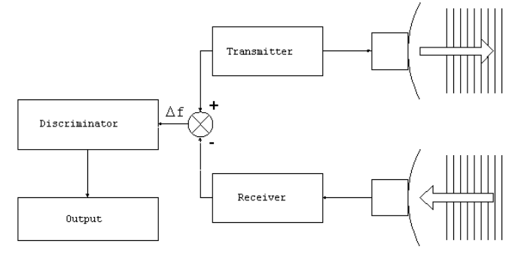

Fig 1.1- Basic Principle of Radar

The range to a target is determined by the time it takes for a radar signal to travel to the target and back. Suppose TR is the time taken by the signal to travel to a target situated at a distance R and back. Thus the total time taken is given by =2R/c.

Radar waveforms are divided into two classes: continuous wave (CW) and pulsed. Both classes are representative of the process of a waveform being repeatedly modulated onto multiple segments of a transmitted signal. The purpose of this is that the segments can be combined on receive to increase the gain and to enable discrimination in Doppler. The CW waveform is continually being transmitted, which means that the waveform-modulated segments do not take turns with the receive operation. Transmission and receive occur simultaneously in this case. This type of radar is often used in a bistatic configuration in order to maintain isolation between the receiver and the transmitter.

In contrast, a pulsed radar transmits a waveform over a short period of time, known as the pulsewidth T (generally on the order of microseconds), and then stops transmission for a period of time. The pulsewidth is required to be less than the pulse repetition interval (PRI), denoted TPRI. The duty cycle is determined from the ratio of the pulsewidth and the PRI as

= T / TPRI = T ·PRF

where the inverse of the PRI yields the PRF, the pulse repetition frequency. This implies that CW radar can be considered as a special case of pulsed radar where dt = 100%. During each pulse repetition interval, the transmitter alternates between transmit and receive intervals so that echoes from objects in the environment can be collected.

Preferably, most radar systems codes should permit long detection range and fine range resolution. Therefore we have to transmit an extremely narrow pulse (high bandwidth) of exceptionally high peak power if we use short pulses. However there are practical limits on the peak power. To obtain long detection ranges for pulse delay ranging, very high power pulses must be transmitted. One solution to this dilemma is to use pulse compression. Which means, transmit internally modulated pulses of sufficient bandwidth to provide the necessary average power at a reasonable level of peak power (as we showed in chapter 2). Then, after reception, “compress” the received echoes by decoding their modulation. Linear frequency modulation (LFM) or often called chirp is the first and probably still the most common method for transmitted pulse.

An important function of a radar is its ability to resolve targets, and one way of assessing the quality of this type of measurement is through the range resolution. Range resolution is defined to be the ability of the radar to distinguish two or more targets that are closely spaced in range [5]. Range resolution is denoted ∆R, which by definition is the spacing between two targets that is required to be able to resolve them in range. If the targets are spaced by less than ∆R then it is not possible to resolve each target. The quantity ∆R is defined as

∆R = c T / 2

the range resolution is dependent on the duration of the pulse, hence the shorter the pulse, the finer the range resolution.

. Overview of the development of Direction of Arrival (DOA) Initially, the Direction of Arrival Estimation estimated the linear spectrum based on the method of Fourier transform. It mainly included the periodogram method. Because it was affected by the Rayleigh limit, it could not acquire a high-resolution performance, or resist the noise, so it did not obtain satisfied performance. Afterwards, based on the statistical analysis of maximum likelihood spectrum estimation, which has a high-resolution performance and robust character, people began to pay attention to this method. However, maximum likelihood estimation needs to search for a high-dimensional parameter space, which means that abundant calculations are required. Therefore, it is hard to be put into practice [8]-[10] . In 1967, Burg proposed the maximum entropy estimation method, which opened a modern research area on spectrum. This method includes maximum entropy, AR（ Autoregressive model）, MA（Moving Average Model）, ARMA（Auto-Regressive and Moving Average Model）parameter method. All those methods have a high resolution. Nevertheless, they all need a large amount of calculation and a low robustness. [9, 10] . When it came to the 1980s, the academic community put forward a series of spectrum estimations based on decomposition of eigenvalues. All those estimations were represented by Multiple Signal Classification (MUSIC) and Estimation Signal Parameters via Rotational Invariance Technique (ESPRIT) [11, 12]. In certain conditions, MUSIC is a one-dimensional implementation of maximum entropy, which shares the same character with maximum likelihood method [13, 14] . At that point, MUSIC was better than any other methods and received more and more appreciation. However, it has a weakness of heavy computation. ESPRIT arithmetic and its improved arithmetic such as TLS-ESPRTI, VIA-ESPRIT and GEESE have a high resolution. The most important thing is that this kind of arithmetic avoids large computation in search of the spectrum, so it can accelerate the speed of Direction of arrival estimation. However, ESPRIT arithmetic and its improved arithmetic can be achieved only under some special array structures, so its application is relatively narrow [15] . In recent years, some normal methods on DOA, like ML, MUSIC, ESPRIT, have ignored the time characteristic of the signal. Along with the wide application of array signal 3 processing, one signal interferes with other signals in many occasions like in thee field of communications. Therefore, when processing the spatial problem, one should consider the time-domain problem at the same time. Using useful information in the signal more sufficiently, researchers think signals can be sampled in the spatial domain and time domain at the same time. The surplus one dimension to replenish the shortage of spatial domain information, namely use two dimensions to process array signal and reduce the restraint of the array structure and improve the arithmetic ability of resistance to noise. In practice, there is often a coloured noise environment. In recent years people try to use the array signal processing based on higher-order cumulant, since higher-order cumulant has a natural blind feature for any Gaussian noise. Based on the cumulative amount, the algorithm makes the original DOA estimation algorithm expand to Gaussian spatial coloured noise or non-Gaussian noise spatial coloured and white noise [16] . In array signal processing, when antenna array receives multiple signals which form the signal source, the signal source may be completely unknown and the transmission channel is also unknown and time-varying. This unknown feature for the transmission channel is the main reason to limit the high resolution of DOA. So scholars have put forward the concept of blind DOA estimation [17]. Blind DOA estimation can estimate the channel’s characteristics under unknown circumstances, and has broad application prospects. Adaptive blind signal separation began at the pioneering working by Heruah and Juttne in 1991. Since then, people have proposed many different algorithms in recent years. In principle, all these blind separation algorithms can be used for DOA estimation. Many natural and artificial signals, such as voice, biomedical signals, radar and sonar signals are typical of non-stationary signals, whose characteristics are limited by duration and time variation. Considering the nonlinear and non-stationary characteristics in the actual system, use of artificial neural networks in DOA is the research direction in recent years [18] . All these methods basically stay in the theoretical and experimental simulation stage, which is far from actual applications. At present, interferometry is mainly used to estimate DOA. In a variety of DOA estimations which are based on spatial spectrum estimation, the MUSIC method has a higher resolution, a moderate amount of computation, better robustness, and wide application in array structure. In the practical engineering process, people often choose the MUSIC method in experimental studies, and thus develop a number of hardware devices. Certain results have been achieved in the practical process. Spatial spectrum estimation is a specialized signal estimation technology that uses space arrays to achieve a space signal parameter. The entire spatial spectrum system should be composed of three parts: the incident signal space, spatial array receiver and parameter estimation. The space can be divided into three corresponding spaces, namely target stage, observation stage, and estimation stage

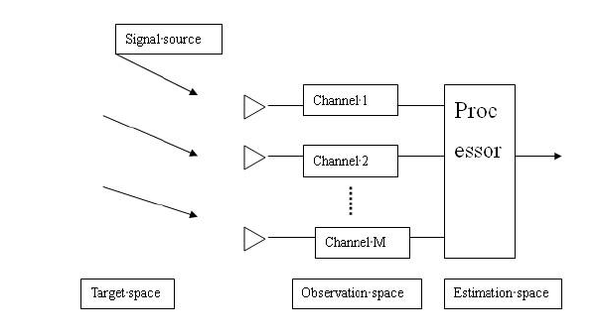

Figure: The system structure of DOA estimation

The above system architecture is described as follows:

1) Target stage is a stage that consists of signal source parameters and a complex environment. For the spatial spectrum estimation system, it uses some particular methods to estimate the unknown parameters of signals which come from this complex target stage.

2) Observation stage is a stage which receives the radiation signals from the target stage. Due to the complexity of the environment, the received data may contain some signal characteristics (azimuth, distance, polarization, etc.) and the space environment characteristics (noise, miscellaneous waves, interference, etc.). In addition, due to the influence of spatial array elements, the data received also contain some features of space array element (mutual coupling, channel inconsistent, frequency band inconsistency, etc.). This observation stage is a multidimensional stage which means that the system receiving dates are composed of plurality of channels, and the traditional time domain processing method is usually only used for one channel. Of particularly note is that the channel does not correspond to the array elements; a spatial channel is formed by several or all of the synthetic array elements. There is no doubt that certain array elements in the stage may be contained within different channels.

3) Estimation stage is a stage which uses spatial spectrum estimation techniques (including array signal processing techniques such as array correction and spatial filtering techniques) to extract the signal character parameters from the complex environment.

Estimation stage is equivalent to the reconstruction of the target stage. The accuracy of reconstruction is determined by many factors, such as the complexity of the environment, the mutual coupling of spatial array, different channels, frequency band inconsistency, etc.

Spatial spectrum expresses the energy distribution of signals in all spatial directions. If one can get the spatial spectrum of the signal, the direction of arrival (DOA) of the signal can be obtained, so spatial spectrum estimation is also known as DOA estimation.

The basic principle of DOA estimation :

DOA is for the direction of array antenna of the radio wave. If the radio wave received meets the condition of far field narrowband, it can take the front of the radio wave as a plane. The angle between the array normal and the direction vector of the plane wave is the Direction of arrival (DOA).

The estimated target of DOA gives N snapshots data: X (1)…X (N), using an algorithm to estimate the value of multiple signals’ DOA (θ).

For generally far and wide signals, a wave-way difference exists when the same signal reaches different array elements. This wave-way difference leads to a phase difference between the arrival array elements. Using the phase difference between the array elements of the signal one can estimate the signal azimuth, which is the basic principle of DOA estimation.

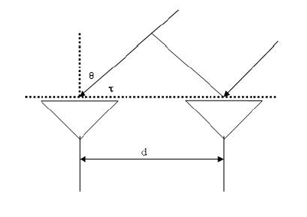

Figure : The principle of DOA estimation

For instance, Fig. 2.2 considers two array elements,

d is the distance between the array elements,

c is the speed of light,

θ is the incident angle of the far field signal,

τ is the time delay of the array element.

The signal received by the antenna due to the path difference is

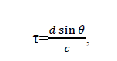

thus one can obtain the phase difference between the array elements as

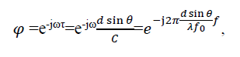

where fo is the centre frequency. For narrow band signals, the phase difference is



where λ is the wavelength of the signal. Therefore, if the time delay of the signal is known, the direction of the signal can be gained according to path difference formula which is the basic principle of spatial spectrum estimation techniques.

In this thesis, the following assumptions are used:

1) Point source assumption. Assume that the signal source is a point source, when looking from the array signal source, the opening angle is zero, and thus the signal source relative to the direction of the array is determined uniquely.

2) Narrowband signal hypothesis. That means that the signal bandwidth is far less than the reciprocal of the signal wave propagation across the largest diameter time. Meeting the narrowband assumption is to ensure that all array elements in the array can capture a signal at the same time.

3) Array assumptions. Assuming the array is located in the far field region of the source, the wave is projected to the plane wave. Assuming each element is the same lattice element and the position is accurate, the array element channel and amplitude and phase are consistent. This assumption guarantees that the array elements and their channel have no error.

4) Noise assumptions. Assuming the noise between each array element is zero, variance σ2 is Gaussian white noise, statistical independently between each array noise and statistically independent between signal and noise.

2.2 Common methods for the array signal DOA

This section describes some common methods for the DOA estimation.

1. Conventional beam forming method

The DOA estimation method was first used in conventional beam forming algorithm. Its main idea is: In a certain time, make all arrays estimate a certain direction and measure the output power; for the output power, produce a maximum power of direction that is needed by DOA estimation .

The main shortcoming of the conventional beam forming method is that: all the freedom degrees in the array are used to form a beam in the desired direction of observation. When multiple signal sources are incident, the method is limited to the height of the beam width and the side lobe, so the resolution is low.

2.Capon minimum variance method :

Capon minimum variance method is a beam forming technique for the purpose of enhancing the effect of conventional methods .Conventional beam forming methods have a defect: when there are multiple signal sources, spatial spectrum estimation includes the signal source power not only in the estimation direction but also in other directions. And Capon method reduces the influence of interference by minimizing the total output power, and thus estimates the direction of the wave.

Compared with conventional beam forming algorithm, the Capon method has greatly improved resolution .However, the Capon method has obvious shortcomings: if the other signal’s incident direction is close to the interest signal’s incident direction, the Capon method will make many errors. It needs to calculate the matrix inversion. When the number of array elements is large, it needs correlation calculation. The ability to distinguish is decided by the array geometry and SNR.

3. Eigenspace algorithm

Although the classical beam forming method is usually very effective and frequently used, these methods have essential limitation in terms of resolution, by the array aperture limit. Most of these limitations are due to the model structure of input signal. Schmitt derived the completely geometric solution of DOA estimation without considering the noise situation, and promoted this geometric solution, finally obtaining a reasonable approximate solution when noise existed and creating a precedent for the eigenspace algorithm. This algorithm is later developed into MUSIC algorithm. Except for MUSIC algorithm, the formation of eigenspace algorithm is mainly due to rotational invariance techniques by means of signal parameters estimation, which was proposed by Roy. It is called the ESPRIT algorithm [24].

There are two properties when eigenspace algorithm mainly uses an array of received data covariance matrix R.

1) Expansion space of feature vectors can be decomposed into two orthogonal subspaces, the signal subspace (expansion by the larger eigenvector corresponding to the larger eigenvalue) and the noise subspace (expansion by the smaller eigenvector corresponding to the smaller eigenvalue) 2) The direction vector from the signal source is orthogonal with the noise subspace.

Number of array elements : The number of array elements in basic arrays can affect the estimation performance for super resolution algorithm. Generally speaking, if array parameters are the same, the more number of array elements, the better estimation performance for super resolution algorithm.

In the time domain, the number of snapshots is defined as the number of samples. In the frequency domain, the number of snapshots is defined as the number of time sub-segments of discrete Fourier transform (DFT).

SNR :

Assuming the signal and noise have a flat pass band power spectral density, and the power of signal source is σ2p, noise power isσ2n, then in this case SNR can be defined as

SNR=20 log (𝜎𝑃𝜎𝑛), (2.4)

SNR directly affects the performance of super-resolution DOA estimation algorithm. At a low SNR, super-resolution algorithm performance would drop dramatically. As thus, how to improve the algorithm under a low SNR is the research focus for the sup-resolution DOA algorithm [26]. The coherence of the signal source

The problem involving coherent sources is a fatal problem for subspace algorithms. When there is a coherent signal in the signal source, the signal covariance matrix is no longer for the non-singular matrix. In this case, the original super-resolution algorithm will fail. Therefore, it will greatly affect the performance of DOA estimation. In addition to the factors mentioned above, many other factors can affect the performance of DOA estimation in practical applications, such as the array element amplitude and phase inconsistencies, mutual coupling between array elements, and the wrong position of sensors.

Resolution :

In the direction of array, the resolution of the signal source on one direction is directly related to the rate of change in the vicinity of the array direction vector. In the vicinity of the rapid changes direction vector, with the change of signal source angle, the snapshots also change; the corresponding resolution is high. Here a sensitivity characterization D(θ) is defined,

D(θ)= ‖ⅆ𝑎(𝜃)ⅆ𝜃‖ ∝ ‖ⅆ𝜏ⅆ𝜃‖,

where 𝑎(𝜃) is the incident angle of array elements. The larger D(θ) indicates the higher resolution in this direction.

For uniform linear array (ULA)

D(θ) ∝ cos(𝜃

It shows that signals have a sensitivity that is reduced to half in 60°, so the scope of the general linear measurement is from -60°to 60°.

Hermitian matrixes :

Definition: If the complex matrix A satisfies AH=A (H denotes the conjugate transpose), then A is a Hermitian matrix .

DOA estimation is one of the most important research problem in various applications like radar, sonar, communications etc., Estimation algorithms of DOA depend upon maximum likelihood and subspace decomposition approaches .Subspace-based (or super-resolution)approaches have attracted much attention, after the work in [4]is computationally simple as compared to the ML approach..There are number of algorithms for subspace DOA estimations which are shown in the below figure.

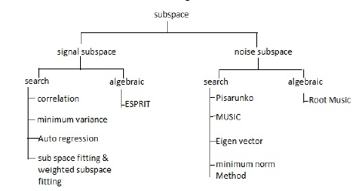

Fig.. Different methods of DOA estimation

In signal subspace methods, only signal subspace information is retained while in noise subspace based methods, only noise subspace information is retained. These subspace methods are divided into search based and noise based methods. In search-based methods, it is assumed that the response of the array to a single source, the array manifold a(θ), is either known analytically as a function of arrival angle, or is obtained through the calibration of the array. Algebraic methods don’t require a search procedure and yield DOA. estimates directly. One of the subspace method used for DOA estimation is ESPRIT (Estimation of Signal Parameters via Rotational Invariance Techniques) [5]: The ESPRIT algorithm requires “translational invariant” arrays, i.e., an array with identical copy displaced in the space. The geometry and response of these arrays need not be known; only the measurements from these arrays and the displacement between the identical arrays are required. The computational complexity of ESPRIT is less compared to search-based methods. In Root-MUSIC, the array is required to be uniform and linear with search procedure in music is replaced by root finding approach. MUSIC (Multiple Signal Classification) method has high resolution but it is a non - linear spectral method. This method is basically implemented in spatial domain as a method for Direction of Arrival (DOA) estimation and parameter estimation of superposed radio signals on the antenna array. MUSIC method is of specific theoretic and practical interest to the researchers, reason being its high resolution properties and accurate performance. MUSIC method is a subspace method. The high resolution properties of the MUSIC method are based on its special properties and ability to decompose into two orthogonal subspaces (signal subspace and noise subspace).

MUSIC method provides asymptotic unbiased estimation of parameters in the spatial model of multiple signal superpositions. It means that, in case of direction of arrival estimation problem, when the number of spatial-time samples of the signals in the asymptotic case if tends to be infinity, implies the Standard deviation of estimation error of the DOA estimation tends to lower Cramer-Rao's bound and mean value of the estimation error tends to zero. MUSIC method can be applied to the DOA estimation when the antenna array is of non-uniform geometry, so that the spatial sampling of the wavefront is non-uniform. A good advantage of this method compared to the DFTmethod is that the spatial (time) sampling of wavefront (signal) can be non-uniform. By using this method to the systems for radiofrequency spectrum monitoring, a problem ofsignal detection and parameter estimation in multiple incident signal scenario can be solved in a new qualitative approach. These problems are difficult to solve using classic spectrum analysis, especially in the case when radio signals are fully or partially overlapping both in time and frequency domains. By using the MUSIC method in the analysis of spatial samples of wavefront, the following unknown parameters of superposed radio signals can be estimated: the number of superposed (active) radio signals in the given frequency band and parameters of each superposed signal such as: spectral bandwidth, direction of arrival (both azimuth and elevation) and polarization. The process of finding estimate of spectral bandwidths of multiple incident signals in open references is called ‘band or spectrum segmentation.

The technique of pulse compression was developed during the mid-1950’s in order to mediate the need to trade off between the contradictory benefits of a short-duration pulse as compared with long-duration pulse [6]. Specifically, since bandwidth of a pulsed, sinusoidal waveform is inversely related to pulse duration,there is an implied advantage for using a short pulse to achieve more fine range resolution. However, received signal strength is proportional to pulse duration, which conversely implies a benefit to using a long pulse, thus ensuring enough energy on target to provide a detectable signal-to-noise ratio (SNR) [6]. Pulse compression is a solution to this dilemma because it employs a longer pulse that has been modulated to yield a bandwidth corresponding to a short-duration pulse. Thus, the range resolution of a wide-bandwidth waveform can be achieved without requiring a high power transmitter because the energy and resolution of a waveform have been decoupled [5]. After appropriate receive processing is applied to the reflected version of a transmsitted waveform (assume for now from a single point scatterer) the response will have a mainlobe with resolution corresponding to that of a short pulse

While there are numerous types of pulse compression waveforms in existence, they can be generally divided into a few categories. These general categories are frequency modulated (FM) waveforms, phase codes, frequency codes, and random noise waveforms. One of the most commonly used of these categories in actual radar systems are the FM waveforms.

Within the category of frequency modulated waveforms, the linear frequency modulated (LFM) waveform is arguably one of the most widespread in its use because of its straightforward implementation in hardware. Another attractive feature of this waveform is the ability to apply stretch processing on receive . for a good range resolution we need to keep the duration of a pulse small. But the problem with short pulses is that it will not be possible to put enough energy on this pulse. Sufficiently wide pulse cannot achieve a wide bandwidth because if we are using an unmodulated pulse having constant frequency, its time duration will be very small and will not be possible to enough energy on it. This problem can be solved by using a modulated pulse of sufficient duration so that it will provide the required bandwidth for the operation of radar. The most common waveform used for this purpose is the LFM (Linear frequency modulated) pulse also known as the chirp pulse. .This waveform repeats itself in every interval called PRI (pulse repetition interval) or also known as pulse repetition period .The LFM signal taken over here is given by:



To derive the expression for the linear FM waveform, it is necessary to start with the complex baseband representation of a general FM waveform with pulsewidth T (normalized to unit energy)



The instantaneous phase is θ(t) and the instantaneous frequency, f(t), is determined from its derivative

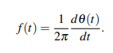

In the specific case of an LFM waveform, which is often called a chirp, it has a phase function



with B the approximate 3 dB power bandwidth for the waveform. The selection of either + or − is simply the determination of having either an up-chirp (increasing frequency over time) or a downchirp (decreasing frequency over time). As can be seen below, it is a linear function of frequency, as the name of the waveform implies,



The chirp rate, denoted k, of an LFM waveform is defined as the rate of change of the frequency with respect to time, and is determined by taking another derivative, this time of the instantaneous frequency function. For an LFM, the chirp rate is a constant value, k = B/T, which indicates that the waveform sweeps linearly across the bandwidth B during the pulse width T results in the complex baseband LFM waveform (assuming up-chirp)



Using the real portion of this signal, a time-domain plot of the signal can be created, as shown in

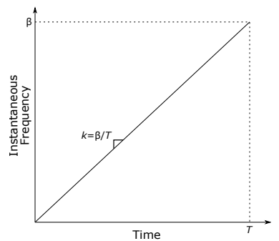

Figure 2.5: Instantaneous frequency versus time for an LFM waveform defined from 0 ≤ t ≤ T with chirp rate k.

For practical application of an LFM waveform, the pulse is centered at a radio frequency (RF), fRF and can be expressed as

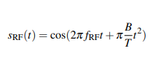

It is useful for analysis purposes to represent the frequency domain of the LFM signal, and as with many things, there is a useful approximation that can be applied.

**CHAPTER-3**

**LITERATURE REVIEW**

**[1] Fang Ye, Yibing Li, Shenyuan Yang:**

This paper puts forward a new technique for LFM signal process, which has practical applied importance.,Linear frequency modulation (LFM or chirp) signals are widely used in information systems, how to detect and estimate LFM signals is an important problem. However, using traditional array signal process couldn't commendably estimate DOA of LFM signal, because which is a nonstationary signal. Aim at this problem, the paper combined array signal process and fractional Fourier transform (FRFT), proposed extracting signal from the mixture of sources and noise using time-frequency revolving characteristic of FRFT. Then obtained unambiguous initial frequency and frequency modulation slope estimates from the output of the reference element, while combining music arithmetic to estimate 2-D DOA.

**Summary:**

This paper combines the time-frequency analysis method with array process algorithm to process LFM signals. It puts forward a new method to separate the LFM signals in time-frequency domain as well as estimate DOA. In the method, a time-frequency represented array data model is formed by FRFT ofthe output of a reference sensor and those of two sub-arrays, then the subspace based methods are applied to get DOA estimates of multiple sources.

**[2] Deliang Liu,Xiwei Guo,Peng He,Shen Zhao:**

This paper Conventional DOA estimation approaches suffer from low-angular resolution or relying on a large number of snapshots which are unavailable in numerous practical applications such as underwater array processing. The sparsity-based IAA can work with a few snapshots and has high resolution and low sidelobe levels, but it is only applied to narrowband signals. To solve the above problem, a new FrFT-IAA method was proposed to estimate the DOA of wideband chirp signals with high resolution based on a few snapshots. First, the wideband chirp signal was taken on the Fractional Fourier Transform (FrFT) under a specific order so that the chirp wave in time domain could be converted into sine wave with a single frequency in FrFT domain. Then the steering vector of the received signal can be obtained in FrFT domain. Finally, IAA algorithm was utilized with the obtained steering vector to estimate the DOA of the wideband chirp with a few snapshots. The simulation results demonstrate the effectiveness of the proposed method.

**Summary:** Here,the wideband chirp signal was taken on the Fractional Fourier Transform (FrFT) under a specific order so that the chirp wave in time domain could be converted into sine wave with a single frequency in FrFT domain. Then the steering vector of the received signal can be obtained in FrFT domain. Finally, IAA algorithm was utilized with the obtained steering vector to estimate the DOA of the wideband chirp with a few snapshots.

**[3]** [**Ning Ma**](https://www.researchgate.net/profile/Ning-Ma-69)**,** [**Joo Thiam Goh**](https://www.researchgate.net/profile/Joo-Goh)**:**

Various methods are available to perform direction-of-arrival (DOA) estimation for random sources. However, the work on DOA estimation of deterministic sources, such as broadband chirp signals, is quite limited. This paper proposes two novel methods for broadband chirp DOA estimation (BCD), namely the incoherent broadband chirp DOA estimation (BCD-I) and coherent broadband chirp DOA estimation (BCD-C). The proposed methods exploit the time-frequency structure of the chirp signal via the ambiguity function, which converts the absolute time and frequency of the chirp signal into relative time lag and frequency difference. The algorithms can be applied to arrays of any aperture size and arbitrary chirp rate signals. The signal frequency of the source can be higher than the conventional array design frequency, and the number of sources can be greater than the number of sensors as long as the signals are separable in the ambiguity function plane. These methods can be applied to single or multiple chirps with the same or different chirp rates. The performance analysis shows that our algorithms generally provide improvements in the DOA estimation of the broadband chirp sources.

**Summary:** In this paper, studied about two novel methods for estimating broadband chirp DOA, namely the incoherent broadband chirp DOA estimation (BCD-I) and coherent broadband chirp DOA estimation (BCD-C). The methods make use of the time-frequency structure of the chirp signal based on the ambiguity function.

**[4] Petre Stoica, Prabhu Babu, and Jian Li**:

In this paper,separable models occur frequently in spectral analysis, array processing, radar imaging and astronomy applications. Statistical inference methods for these models can be categorized in three large classes: parametric, nonparametric (also called “dense”) and semiparametric (also called “sparse”). We begin by discussing the advantages and disadvantages of each class. Then we go on to introduce a new semiparametric/sparse method called SPICE (a semiparametric/sparse iterative covariance-based estimation method). SPICE is computationally quite efficient, enjoys global convergence properties, can be readily used in the case of replicated measurements and, unlike most other sparse estimation methods, does not require any subtle choices of user parameters. We illustrate the statistical performance of SPICE by means of a line-spectrum estimation study for irregularly sampled data.

**Summary:** The SPICE (semiparametric/sparse iterative covariancebased estimation) method introduced in this paper enjoys global convergence properties, is user parameter free, can be easily used in the multisnapshot case, and has a small computational complexity.

**[5] Z Chen, J Li, P Stoica, KW Lo:**

Sector scan sonars can be used for detection and identification of man-made objects located on the sea floor. Wideband acoustic signals are employed in this kind of sonar system to enhance range resolution. The conventional delay-and-sum beamformer (CBF) produces sonar images with high sidelobe levels and poor angular resolution. Adaptive beamforming algorithms together with spatial resampling can be applied to mitigate this problem. The algorithm “Spatial Processing: Optimized and Constrained” (SPOC), used in a recent work, is studied herein and shown to be identical to the basic form of the FOCal Underdetermined System Solver (FOCUSS) algorithm. A recently developed algorithm, the Iterative Adaptive Approach (IAA), is proposed for this sonar application and various implementation issues are discussed. Experimental results show that the IAA algorithm produces better sonar images than the CBF and Minimum Variance Distortionless Response (MVDR) algorithms in terms of sidelobe suppression and angular resolution. Compared with SPOC, IAA provides clearer acoustic highlights of the imaged object and a higher density of pixels representing the object.

**Summary:** studied about the superior performance of IAA over the CBF and the other two adaptive algorithms (MVDR and SPOC). Sonar images generated with IAA have minimal artifacts, clear acoustic highlights of the imaged object, a high density of pixels representing the imaged object, and a good angular resolution.

**CHAPTER-4**

**EXISTING METHOD**

IAA is a nonparametric adaptive algorithm recently proposed for array processing applications.The Iterative Adaptive Approach is a spectral estimation technique that is based on a weighted least squares minimization. The method was originally proposed for source localization, but has found other applications in imaging, pulse compression, and missing data estimation .IAA assumes that the following general signal model is valid for the data:



Here is our measured data vector, and A = is our steering matrix. Here K represents the grid size in the frequency domain and a steering vector of A can be written as



Here f represents the carrier wave frequency, c is the speed of propagation, and xn is the position of the nth element. is a vector containing the unknown amplitude and phase at each point in the frequency domain; finally, is the noise vector. We are interested in measuring the signal power for k = 1, 2, . . . , K. The signal power matrix P is defined as a diagonal K × K matrix with the values on the diagonal. Using then the noise and interference covariance matrix for the kth grid point can be defined as



where .IAA minimizes the following function with respect to the αk values:



where This is a complicated cost function since the  depends on the αk values. Also notice that the problem decouples for each , hence each can be solved separately for a given .Therefore, IAA takes an iterative approach to solve this problem. We start with some initial estimate of  (typically from a matched filter/delay-and-sum). Then and .The optimal solution then for a given  is:



Using this estimate of α then the matrix  is updated and the process is repeated until some stopping criterion is met. For a more in-depth treatment on the derivation of IAA the reader is encouraged to read . Here a subscript of (i) represents an iteration marker and  is the threshold of our convergence criterion. When  is small then  (where α0 is our initialization value) and we say that IAA has converged, while β is an iteration threshold which sets a maximum number of iterations. In this paper we choose to be 10^−3 and β = 20. For the basic implementation described in this section, we choose wk to be 0 for all k.

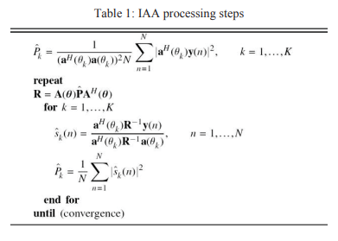

SLIM :This method operates under the assumption that  (which is a reasonable assumption in some applications). The updated estimates for SLIM are iteratively obtained as

SLIM are iteratively obtained as follows:

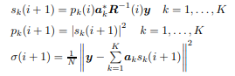  
The initial estimates for are obtained as for IAA, whereas σ(0) is typically chosen as a small positive number (e.g., σ(0) = 10−5 ). Even though derived in the cited papers in a different way, SLIM is similar to the regularized FOCUSS (focal underdetermined system solver) algorithm introduced in [16]. The main difference between these two methods consists in the way they estimate σ : SLIM computes the estimate of σ iteratively as in (18), while FOCUSS uses a fixed estimate of σ in all iterations that is obtained by one of several possible heuristical methods (see [16]). Both IAA and SLIM are known to converge locally to the minimum value of their corresponding criterion (see the proof of local convergence for IAA in [17] and for SLIM in [14]). However little is known about the global convergence of these algorithms, or in effect about the convergence of their associated sequences. The main difference between these two algorithms is that IAA is a non-parametric method (which provides a dense power estimate), whereas SLIM is a semi-parametric method (whose result is a sparse power estimate, due to the use of sparsity-inducing parameter priors that lead to an implicit norm constraint similar to the one in (8), see [14] for details). In particular, the semi-parametric character of SLIM makes its extension to the multi-snapshot case a bit more difficult than that of IAA for which the extension is more or less straightforward (this difference is due to the fact that for a sparse method, unlike for a dense one, the estimates of for different snapshots should maintain the same sparsity pattern versus the snapshot index) ; we refer to [17] for details on these extensions.

MUSIC ALGORITHM :In signal processing, the direction of signal uses beamforming technique to estimate incoming signals that is incident onto the surface. Therefore, it is possible to derive a relationship between the direction of the incoming signals and the associated received steering vector, Beam patterns and excitations of the array antennas, can be correlated in applying this method using frequency domain to calculate the spectral density. In space time domain, DoA can also be used to calculate the spectral density. Assuming in an ideal condition where the array antennas are linear, uniform, and equispaced in a given direction, ξ with N number of elements (# of contacts on a surface) and M number of signals. The assumption is that M signals can never be more than the number of N elements since other sources that interfere with incoming signals are not included in the model. On the other hand, in reality, it would be very difficult to determine the number of signals since there are so many variations impinging on the antenna surface. For the sake of this problem, an ideal scenario will be used to estimate the given the number of signals and the incoming direction incident on the surface. This problem can be solved using variety of estimation techniques, this paper uses Multiple Signal Classification (MUSIC) algorithm which uses adaptive technique to calculate the spectral estimation of the number of signals incident on the surface. The signal can be defined as:



where x is a column vector that describes the combined signal at the output, ξ is the M x N matrix of the M steering vectors, and n is the column vector of the corrupted noise. MUSIC, as are many adaptive techniques, is dependent on the correlation matrix of the data. Since ξ matrix is dependent on the angle of impingement, the matrix S can be written as:



Here α(ϕ) is defined as the column vector of the generated input signal. where, θ and ϕ are the elevation and azimuthal angles of the source position in a radial co-ordinate system, A(θ, ϕ) is the array steering matrix defined by the antenna array’s relative position with respect to the signal source, matrix represents the eigenvectors corresponding to the noise space of the received signal and [·]H represents the Hermitian transpose of a matrix.

The spectrum is clearly maximized at places where noise space and steering matrix are orthogonal to each other. Therefore, the values of (θ, φ) at the corresponding spectrum peaks provide the direction of arrival. Since MUSIC computes the spectrum to separate noise and signal spaces at every possible values of (θ, φ), it involves an extensive search procedure, making it computationally very expensive. Since there are two unknowns in this equation, the electric phase angle,ϕ, and the attenuation constant, ξ, it is required to calculate the spectral estimation of the given signals.



We can then rewrite ξ in terms of phasor notation with a and c coefficients:



where a is defined as the magnitude between the real and imaginary parts and b is the phase angle. where ξ has M signal values. If we assumed that the signals incident on the surface are uncorrelated, then the correlation matrix can be defined as:



where E is the operator that takes the expected value of the signal, x, and the counterpart of the signal, x (Hermitian). Since the signals are uncorrelated, the cross values terms or equal to zero; the only terms remain are the like terms. Simplifying the terms,

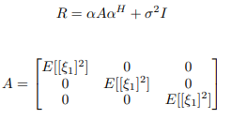

where the matrix A is an N x M matrix composed of the product of the column vector, ξ, and the counterpart of the signal, ξ (Hermitian). The average noise power is defined as σ 2 and the matrix I is an identity N x N matrix. We can simplify equation (8) further by redefining the terms .



with Rα is defined as the signal covariance matrix. To satisfy these conditions, In order to check if the matrix Rα is positive definite there are certain criteria that need to be met. The most common cases is determining the eigenvalues (λ) whether they are positive or not. If all eigenvalues are positive, then the matrix is positive definite since the trace of the matrix is also positive. If there are positive and negative eigenvalues, then a further test is necessary to test whether the matrix is positive definite. Positive definite matrices have inversions and are linearly independent; they also span in the subspace. To satisfy the conditions and for the sake of this concept, the signal covariance matrix must be known since eigenvalues are derived and calculated. Once the eigenvalues are calculated, eigenvectors can be determined using the following equation:



where qm is the M number of column eigenvectors. Premultiply  both sides:



where the middle termcan be defined as one arbitrary term. By defining the value β and simplifying the equation:



we can clearly see that in equation (12) if eigenvectors are positive, therefore, the matrix,β, must be positive as well. Since the M number of eigenvectors makes up the orthogonality between the M number of signals, this generates the highest energy peaks in the frequency domain. The MUSIC power pseudo-spectrum density can be determined by the following:

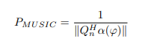

MUSIC is an approximation technique since it relies on the number of taps in order to estimate the energy levels in frequency domain using state-space modeling approach. Since the matrix Rα is not known, but R is an estimate, the eigenvectors Qn can be derived from the eigenvectors R. Using the Weiner-Hopf method,



notice the eigenvectors of Rα is also an eigenvalue of R with the equivalent sum of the eigenvalues and the average noise power. If the matrix Rα is rewritten as:



the following matrix, R can be simplified as:



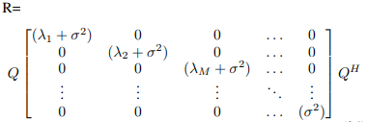

where the (∧+σ 2 I) matrix block diagonals contain λm + σ 2 for all M values and the rest are average signal power for any values greater than M and less than N; everything else is 0. Based on this eigen decomposition, we can partition the eigenvector matrix Q into a signal matrix Qα with M columns, corresponding to the M signal eigenvalues, and a matrix Qn, with (N - M) columns, corresponding the noise eigenvalues (σ2). Note that Qn, the N× (N - M) matrix of eigenvectors corresponding to the noise eigenvalue (σ2), is exactly the same as the matrix of eigenvectors of Rα corresponding to the zero-eigenvalue. This is the matrix used in Eqn. (16).Qα defines the signal subspace, while Qndefines the noise subspace. In general, MUSIC is analyzed in (4) different stages. As given assumption, M number of signals is known. The first stage is the decomposition of the correlation matrix R using equation (15). The second and third stages is to partition the Q matrix to obtain the noise Q matrix with (N-M) smallest eigenvalues since this is needed to plot the power spectral density of MUSIC; plot this using equation (12). The fourth stage is to determine the peaks. For M signals, the bigger the eigenvalues, the larger the peaks are when this is plotted. Since MUSIC is very ideal and the margin of error can range from medium to very high since this requires the user’s defined interaction to set these peaks (incoming M signals) since this requires an extensive algorithm in searching and determining these peaks. In addition, this requires an extensive amount of resources due to large amount of computational in signal processing, which makes MUSIC an ideal controlled environment and not used for practical purposes. To counter this situation, there are several enhanced versions of MUSIC algorithm. The most three common are smooth, root, and cyclic. The m-th signal eigenvalue is given byThe smallest eigenvalues of R are the noise eigenvalues and are all equal to σ 2 , i.e., one way of distinguishing between the signal and noise eigenvalues (equivalently the signal and noise subspaces) is to determine the number of small eigenvalues that are equal. By orthogonality of Q, Qα ⊥ Qn. all noise eigenvectors are orthogonal to the signal steering vectors. This is the basis for MUSIC. Consider the following function of ϕ



implies a very large value when θ is equal to the DoA related to one of the signals. PMUSIC(θ) function is known as a pseudo ”spectrum” provided by MUSIC. In terms of implementation, the MUSIC-DoA first estimates a basis for the noise subspace, Qn, and then determines the L peaks in (23); the associated angles provide the DoA estimates.

A pseudocode for the MUSIC-DoA procedure is described in the Algorithm

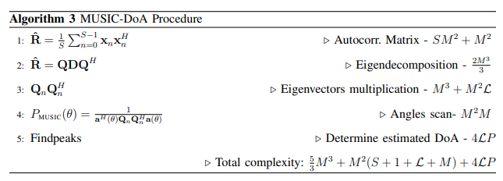

matrix-shifting based techniques are revisited, more specifically Estimation of Signal Parameters via Rotational Invariance Techniques (ESPRIT), which is one of the most widely used method for DoA estimation. As previously mentioned, the MUSIC method uses the noise subspace while ESPRIT deploys the signal subspace in conjunction with a rotational variance technique.The ESPRIT-based DoA estimates are obtained neither nonlinear optimization nor search of any spectral measure; hence, it results in a computational complexity lower than the extrema-searching methods, scanning for all possible angles of arrival.

Conventional ESPRIT Method: The ESPRIT operates under an array of antennas with M elements, divided into sensor doublets. Each sensor is distant d from its respective pair and each doublet is distant ∆ from one another. The doublets can be separated to form 2 sub arrays with m elements in each. The distance d may be different from ∆, which makes it quite dynamic in cases of non-uniform arrays. However, the most commonly used antenna arrays possess sensors uniformly spaced, Then in this work the uniform array configuration has been adopted. The sub arrays are represented by x1 and x2. The output of the x1 and x2 sub arrays is expressed as :

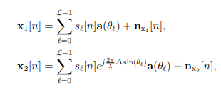

for n = 1, 2, . . . , S samples; besides, x1 and x2 are m × 1 vectors, nx1 and nx2 are the m × 1 vectors representing the noise samples at the input of two sub arrays, respectively. Writing in matrix form, the output of the sub arrays x1 and x2 can be expressed as



whereis a L × L diagonal matrix relating the signals received by the two sub arrays, named the rotational operator .Notice that matrix Φ in above represents an extra delay caused by ∆ on the second sub array x2. Combining both the equations the vector of total array output is formed.

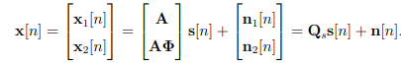

The Qs structure is exploited to estimate the diagonal elements of Φ without knowing A. The Qs columns span the signal subspace of the concatenated sub arrays. Hence, Q = h Qs Qn i is obtained by the eigen-decomposition of R from Eq. (16). If Es is a matrix whose columnsform a basis for the subspace of signal corresponding to the data vector x, then Qs and Es are related by a L × L transformation T [12] expressed by:

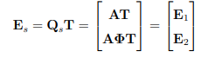

It can be seen that the subspace of E1, E2 and A are the same. So E1, E2 and A have the same range [12]. As a result, a nonsingular L × L matrix Ψ can be defined as



hence Ψ can be defined by:

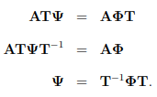

As a result, the eigenvalues of Ψ must be equal to the diagonal elements of the Φ, and T columns are the eigenvectors of Ψ. This is the key relationship in the development of ESPRIT and their properties. The signal parameters are obtained as nonlinear functions of the eigenvalues of the operator that maps Ψ one set of vectors (E1) spanning an m-dimensional signal subspace into another (E2) [12], [13]. Then, since the L eigenvalues φ` of Φ are calculated, the angles of arrival can be computed as:

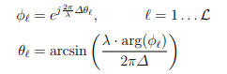



The ESPRIT-DoA procedure estimates a basis for the signal subspace, E1 and E2, then find Ψ, next compute the eigenvalues of Φ, i.e., φ1, φ2 . . . φL and finally compute the DoA applying (30b). A pseudo-code for the ESPRIT-DoA procedure is described in the Algorithm 4, where L is the number of sources, M the number of antennas and S is the number of samples.

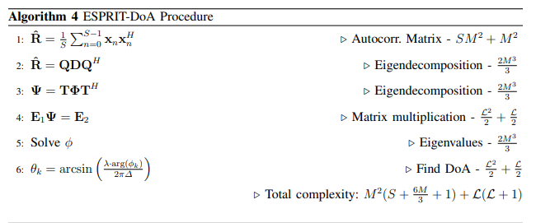

Polarization sensitive array refers to polarized sensitive elements arranged in a particular way in space, and the array can receive spatial and polarized domain information of the source signals. The spatial information can be expressed by the phase delay between different elements, but the polarization information needs to analyze the structure of the polarized sensitive elements. Polarization sensitive elements can receive six electromagnetic components most at the same time, but there will be some redundancy. By the relationship between the electric and magnetic field, a part of the components can be selected to form the element, but the polarization information of the electromagnetic wave signals can be obtained at least two components [16]. Therefore, it is usual to form a uniform linear array with orthogonal cross dipoles, This structure is relatively simple and easy to achieve. The polarization information of the electromagnetic wave signals can be expressed by the amplitude ratio and the phase difference of two mutually orthogonal electric fields, i.e



where represents the ratio of electric field amplitudes between the y-direction and the x-direction, in addition,η = ϕy − ϕx represents the phase difference of electric field between the y-direction and the xdirection. Regardless of the energy information of the electromagnetic wave, the polarization parameter (γ, η) can represent the polarization information of any state. When there are k signal sources inciding N elements array antenna and the noise is independent and stationary, the received signal can be expressed as

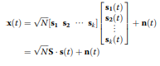

represents the polarized-spatial domain joint steering vector of received signals, Sp is polarized domain steering vector, and Ss is spatial domain steering vector, symbol ⊗ represents kernel product of Sp and Ss. The polarized domain steering vector can be expressed as



and the spatial domain-oriented vector can be expressed as



Spatial polarimetric time-frequency distributions The Cohen’s class of STFD of a data vector x(t) is expressed as



where φ(t, τ) is the time-frequency kernel function and it uniquely be used to define time-frequency distributions. From the knowledge of time-frequency transform and the polarization sensitive array model introduced above mentioned, we can see that for the kth dual polarized orthogonal dipole, the self-term and cross-term time-frequency distributions can respectively be expressed as:

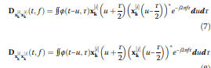

where the superscript i and j both represent the vertical component v or the horizontal component h of the array element. Therefore, the time-frequency distribution of the kth dual polarized orthogonal dipole is a 2 × 2 matrix, which consists of the vertical and horizontal oscillator’s self-term and cross-term time-frequency distributions. Considering a uniform linear array consists of n dual polarized orthogonal dipole, the received data vector can be expressed as



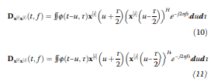

Spreading Formula in accordance with the horizontal and vertical component, we can get the following formula

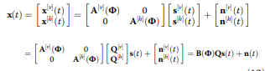

It is clear that the dual polarized orthogonal dipole element has more available information than the unipolar element. After theoretical analysis, we can combine the spatial, polarized, and time-frequency domain information of the signal received by the polarization sensitive array. Thus, the spatial polarization timefrequency distribution (SPTFD) of the received data x(t) can be expressed as



Spatial polarimetric time-frequency DOA estimation algorithm :

Polarimetric time-frequency MUSIC In [3], it has been proved that the structure of spatial time-frequency distribution matrix is similar to that of the traditional array covariance matrix. Therefore, the STFD matrix can be applied to the subspace class algorithm instead of the covariance matrix in the MUSIC algorithm, called time-frequency MUSIC algorithm. Similar to the time-frequency MUSIC algorithm, the polarimetric time-frequency MUSIC algorithm, which integrated polarization information, takes the polarization sensitive array for the model and then do time-frequency transform of the received signal shown in

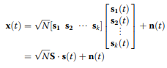

which can obtain the SPTFD matrix. The SPTFD matrix of the corresponding signal can be obtained by sampling each signal along its time-frequency ridge, and the corresponding noise subspace can be obtained by characteristic decomposition. The following summarizes specific steps of the polarimetric time-frequency MUSIC (PTF-MUSIC) algorithm: (1)Performing pseudo-Wigner-Ville time-frequency transform to the polarization data received on the first receive channel and estimating the instantaneous frequencies and the frequency modulation slopes of the incoming wave signals in their timefrequency domain. (2)Using the estimated signal parameters to select points in the time-frequency domain, the different frequency parameters of the signal were selected on their respective time-frequency ridge points to construct their own spatial polarimetric time-frequency distribution matrix. (3)The eigenvalue decomposition, construction of the noise subspace, and construction of the spatial spectrum are carried out on the constructed spatial polarimetric time-frequency distribution matrix, respectively.

However, MUSIC also has the problem of large computational capacity. In order to reduce the computational complexity, the high order power of the inverse of spatial covariance matrix is employed to obtain noise subspace, then Root-MUSIC is used to estimate the directions of the signals, and finally a coefficient of distance is defined to eliminate the false directions

Polarimetric time-frequency ESPRIT Based on the previous study of MUSIC algorithm and ESPRIT algorithm, we know that they both belong to subspace class algorithm, so similar to MUSIC algorithm, ESPRIT algorithm can also be combined with time-frequency analysis integrated polarization information, which is polarimetric time frequency ESPRIT (PTF-ESPRIT) algorithm. The biggest advantage of the MUSIC algorithm is the high accuracy of estimation, while the ESPRIT algorithm as the biggest advantage of fast calculation. Therefore, the PTF-ESPRIT algorithm should have a faster calculation speed than PTF-MUSIC algorithm in theory. The TLS-ESPRIT algorithm is used in this section. The principle of PTF-ESPRIT algorithm is similar to the PTF-MUSIC algorithm. Its algorithm flow is as follows:

(1)Performing pseudo-Wigner-Ville time-frequencytransform to the polarization data received on the first receive channel and estimating the instantaneous frequencies and the frequency modulation slopes of the incoming wave signals in their time frequency domain.

(2)Using the estimated signal parameters to select points in the time-frequency domain, for the different frequency parameters of the signal were selected on their respective time-frequency ridge points to construct their own SPTFD matrix.

(3)The covariance matrices R11 and R22 are obtainedby the SPTFD matrix.

(4)The covariance matrices are decomposed and two signal subspaces E1 and E2 are obtained, then combine them into a new matrix  =[E1 E2 ].

(5)Construct the matrix  and characterize it, we can get the feature matrix E, E can be divided into four P × P dimensional matrix.

(6)Calculate  and characterize it, we can get P eigenvalues. And the wave direction information of signals can be obtained according to the formula k = 2πd sin θk/λ.

**DISADVANTAGES OF EXISTING METHOD:**

**1.More time to estimate DOA:** MUSIC algorithm need for a larger angle range for peak search, coupled with the complexity of the time-frequency transform, it takes a long time to get the DOA estimation of the incoming wave signals. MUSIC also has the problem of large computational capacity.,requires large amount of snapshots,

**2.Accuracy is not Good**: The estimation accuracy of ESPRIT algorithm, is not so good

**3.Computational Complexity**:MUSIC also has the problem of large computational capacity

4.These methods is not able to provide high-angular resolution depending on very low snapshots.

**CHAPTER-5**

**PROPOSED METHOD**

Let us consider an active radar system as shown in Fig.. The linear array of the radar has M sensors uniformly placed along the x axis. The transmitter is located at the origin point. The distance between two adjacent sensors is d. T1, T2, …, TK are K Farfield targets at θ, where θ = [θ1, θ2,…, θK]. Here K is usually unknown, so it is considered to be the amount of potential targets (scanning points) in the region, and it is much larger than the amount of actual ones. Only a few signal power estimates of the potential targets will be non-zero, so sparsity-based algorithm can be used in array processing applications. The transmitter emits a LFM signal that can be

expressed as



where a is the signal amplitude, f0 is the centre frequency, and μ is the chirp rate.

The received signal at the sensor m can be expressed as the sum of K delayed versions of x(t), given by



where for m = 1, 2, …, M is the additive Gauss white noise at the sensor m, ρk is the backscattering coefficient of target k for k = 1,2,…,K. τmk is the time delay of the kth signal traveling to the sensor m relative to the reference sensor (the first sensor), which can be expressed as



where c is the wave speed.



Fig:The geometry of the array system

The received signals at the sensors can be written in

matrix form as



where s(t) = [ s1(t), s2(t), … , sK(t)]T is the waveform vector, a = [a(θ1), a(θ2),…, a(θK)]T is the steering vector

with

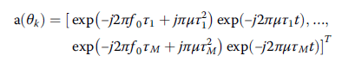

If the bandwidth is small compared to the carrier frequency, a(θk) can be considered as time-invariant (i.e.,

the term exp(-j2πμτmt) in (5) can be neglected), but for wideband LFM, it can not. So, the steering vector a(θk)

of wideband LFM depends on the time t, and the SPICE algorithm for narrowband signals cannot be applied directly to wideband signals. To solve this problem, we derive FrFT method.

The fractional Fourier transform of LFM signal

The FrFT of signal x(t) is represented as



Where

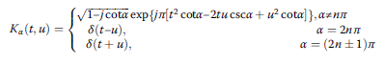

with p is the transform order, Fp is the FrFT operator, Kα(t,u) is the kernel function, α is the rotation angle, α =

pπ/2.

As a generalization of the standard Fourier transform, the FrFT can be regarded as a counterclockwise rotation

of the signal coordinates around the origin in the timefrequency plane, and the rotation angle is α. When α =2nπ + π/2, FrFT is equal to Fourier transform. The FrFT of x(t) in (1) about angle α can be represented

as

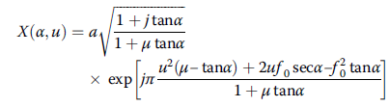

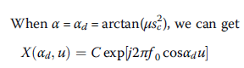

where sc is the scale factor to normalize signals, we use Ozaktas’s fast sampling-type discrete FrFT, method [14] to compute the digital values for FrFT, so,

here, with N denotes the number of snapshots, fs is the sampling frequency, which is a constant. Therefore, after the FrFT, the LFM signal becomes a sine wave with a single frequency Simulation is run to prove this dechirp property of FrFT with f0 = 2.4 MHz, μ0 = 8 × 1013Hz/s, fs = 600 MHz, N = 301.. The LFM signal in time domain is changed into a sine signal in FrFT domain with rotation angle αd.

According to the time shift characteristic of FrFT, we can get



At the sensor m, the received signal in FrFT domain which is reflected by target k can be expressed as

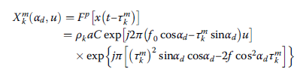

Because is very small, so we can get

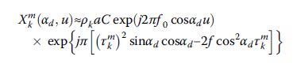

Then can be reformulated as













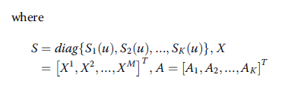

After FrFT, the steering vector will not depend on u, so mwe can use the SPICE algorithm to estimate the DOA values θk.

DOA estimation by FrFT-MSPICE:

The discrete form



where n = 1, 2,…, N is the number of snapshots. Let P be a K × K diagonal matrix, whose diagonal contains

the power at each angle on the scanning grid. The initial estimates can be obtained using the SFLS

method

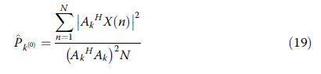

The noise covariance matrix R of X(n) can be given as



Then in the i + 1 iteration, the power at each angle on the scanning grid can be updated as

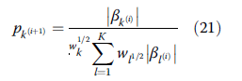

Where



Then iterate eqns until will not change obviously. Finally, we search the positions of the spectral peak of which are the final DOA estimates. The details of SPICE algorithm can be found . It is obvious that the accuracy of the DOA estimation depends very much on the angular scanning grid size. The higher accuracy we need, the smaller the grid size is, which means K is larger. But increasing K will dramatically increase the computational complexity of the algorithm. Inorder to make the DOA estimation more accurate without increasing too much complexity, we utilize the energy centrobaric modification method which is commonly used for modification of the frequency estimation in discrete spectrum. Actually, because the existence of noise, when SPICE scans angles around the real DOA value, the energy estimation will not be zero, which means there is “energy leakage” around the real DOA in the angular spectrum.

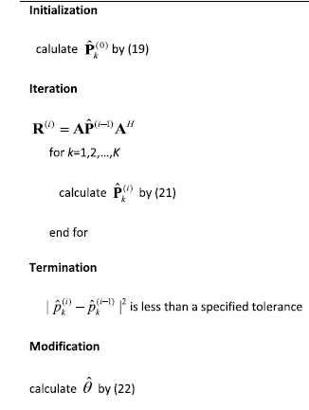

Suppose that there is a peak at k = k* with the energy Pk* in the angular spectrum. Then, we search for Pk * ', which is the largest Pk around k*. Finally, we utilize these two spectral lines to estimate θ. But if Pk * + 1 and Pk * − 1 are nearly equal, we consider θ = k*, and it does not need modification.

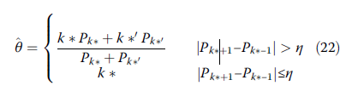

**CHAPTER-6**

**ADVANTAGES AND APPLICATIONS**

**Advantages:**

1. Estimate the DOA for wideband LFM signals using a few snapshots
2. Provide high-angular resolution.
3. Accuracy is good.
4. Low complexity.

**Applications:**

1. Information systems.
2. underwater array processing.
3. sonar, radar, and wireless communication.

**CHAPTER-7**

**MATLAB**

**7.1 INTRODUCTION TO MATLAB**

**What Is MATLAB?**

MATLAB is an elite dialect for specialized registering. It incorporates calculation, representation, and programming in an easy to-utilize condition wherein issues and preparations are communicated in herbal numerical documentation. Run of the mill utilizes comprise

• Math and calculation

• Algorithm advancement

• Data obtaining

• Modeling, re-enactment, and prototyping

• Data examination, investigation, and representation

• Scientific and designing illustrations

• Application advancement, including graphical UI building

MATLAB is an intuitive framework whose important statistics aspect is an show off that does not require dimensioning. This allows you to tackle several specialized processing issues, particularly those with framework and vector info, in a small quantity of the time it'd take to compose a program in a scalar non intuitive dialect, as an instance, C or FORTRAN.

The call MATLAB stays for grid studies facility. MATLAB changed into first of all composed to present easy access to framework programming created by way of the LINPACK and EISPACK ventures. Today, MATLAB motors fuse the LAPACK and BLAS libraries, inserting the cutting side in programming for network calculation.

MATLAB has advanced over a time of years with contribution from several customers. In university situations, it's far the usual academic apparatus for early on and propelled guides in mathematics, designing, and science. In enterprise, MATLAB is the tool of choice for excessive-profitability studies, advancement, and exam.

MATLAB highlights a collection of more utility-specific arrangements known as tool booths. Important to most clients of MATLAB, device kits permit you to learnandapply particular innovation. Tool compartments are exhaustive accumulations of MATLAB capacities (M-records) that reach out the MATLAB condition to take care of precise training of problems. Territories in which tool stash are reachable include flag coping with, manipulate frameworks, neural structures, fluffy reason, wavelets, pastime, and severa others.

**The MATLAB System:**

The MATLAB system consists of five main parts.

**Development Environment:**

 This is the set of tools and centres that help you operate MATLAB features and files. Many of that gear are graphical person interfaces. It includes the MATLAB desktop and Command Window, a command history, an editor and debugger, and browsers for viewing assist, the workspace, files, and the hunt direction.

**The MATLAB Mathematical Function:**

This is a great collection of computational algorithms ranging from standard capabilities like sum, sine, cosine, and complex arithmetic, to extra sophisticated features like matrix inverse, matrix eigen values, Bessel functions, and speedy Fourier transforms.

**The MATLAB Language:**

This is a high-level matrix/array language with control flow statements, functions, data structures, input/output, and object-oriented programming features. It allows both "programming in the small" to rapidly create quick and dirty throw-away programs, and "programming in the large" to create complete large and complex application programs.

**Graphics:**

MATLAB has considerable centres for displaying vectors and matrices as graphs, as well as annotating and printing those graphs. It consists of high-stage functions for 2-dimensional and 3-dimensional records visualization, photograph processing, animation, and presentation graphics. It also consists of low-stage capabilities that will let you absolutely customise the appearance of graphics as well as to construct complete graphical person interfaces for your MATLAB programs.

**The MATLAB Application Program Interface (API):**

This is a library that allows you to put in writing C and Fortran applications that have interaction with MATLAB. It consists of facilities for calling workouts from MATLAB (dynamic linking), calling MATLAB as a computational engine, and for studying and writing MAT-documents.

**7.2 MATLAB WORKING ENVIRONMENT:**

## MATLAB DESKTOP:

Matlab Desktop is the principle Matlab application window. The desktop consists of five sub windows, the summon window, the workspace program, the existing catalog window, the order records window, and at the least one figure home windows, which can be proven simply while the consumer suggests a sensible.

The order window is the area the customer sorts MATLAB orders and expressions at the initiate (>>) and wherein the yield of these fees is shown. MATLAB characterizes the workspace because the association of factors that the customer makes in a work session. The workspace software demonstrates these elements and some statistics approximately them. Double tapping on a variable within the workspace application dispatches the Array Editor, which may be applied to get data and salary instances modify sure homes of the variable.

The present Directory tab over the workspace tab demonstrates the substance of the existing registry, whose way is seemed within the present index window. 1For case, within the windows running framework the manner may be as consistent with the subsequent: C:MATLABWork, demonstrating that registry "paintings" is a subdirectory of the primary catalog "MATLAB", which is delivered in pressure C. Tapping on the bolt inside the present index window demonstrates a rundown of as of past due utilized approaches. Tapping at the seize to one aspect of the window enables the client to exchange the existing catalog.

MATLAB utilizes an inquiry way to discover M-data and different MATLAB related documents, which might be sort out in catalogs within the PC file framework. Any file keep strolling in MATLAB must dwell inside the ebb and go with the flow registry or in an index that is on are trying to find manner. Of direction, the statistics supplied with MATLAB and math works device kits are included into the inquiry way. The least stressful method to look which indexes are at the inquiry manner. The handiest method to peer which catalogs are soon the quest way, or to encompass or regulate an inquiry manner, is to pick set manner from the File menu the computer, and after that utilization the set way exchange container. It is exquisite exercise to add any typically utilized catalogs to the pursuit way to hold a strategic distance from again and again having the exchange the existing index.

The Command History Window contains a record of the orders a client has entered in the charge window, including both present and past MATLAB sessions. Already entered MATLAB orders can be chosen and re-executed from the charge history window by right

tapping on a summon or arrangement of orders. This activity dispatches a menu from which to choose different choices notwithstanding executing the orders. This is helpful to choose different choices notwithstanding executing the summons. This is a valuable component while trying different things with different orders in a work session

**Using the MATLAB Editor to create M-Files:**

The MATLAB manager is both a word processor unique for making M-statistics and a graphical MATLAB debugger. The proofreader can display up in a window without everybody else, or it could be a sub window in the laptop. M-facts are intended by means of the expansion .M, as in pixelup.M. The MATLAB editorial manager window has various draw down menus for errands, for instance, sparing, seeing, and troubleshooting documents. Since it plays out a few basic checks and furthermore utilizes shading to separate between exclusive additives of code, this content device is suggested as the equipment of selection for composing and changing M-capacities. To open the proofreader, sort regulate at the incite opens the M-report filename.M in a supervisor window, organized for altering. As referred to before, the record has to be inside the momentum catalog, or in an index within the pursuit manner.

**Getting Help:**

The important technique to get help on line is to utilize the MATLAB assist application, opened as a exclusive window both via tapping at the query mark image at the computing device toolbar, or by using writing help program on the provoke within the order window. The help Browser is an internet application coordinated into the MATLAB computing device that shows a Hypertext Markup Language (HTML) statistics. The Help Browser contains of two sheets, the assistance pilot sheet, used to find out data, and the show sheet, used to look the statistics. Clear as crystal tabs aside from pilot sheet are applied to play out a pursuit. Second, within the motion pictures taken via transferring camera setup, the state of affairs becomes extra complex because the heritage may additionally exchange by using shifting shot, we cannot tune item motion exactly inside the sum of distinction map. Therefore, in this situation, the purpose is executed through reusing the previous seam and applying it to the cutting-edge body. In order to discover the seams, we use the preceding seam from previous body to look the modern-day seam in contemporary frame. our method is using a seam computed in frame1 (in crimson) to go looking a comparable seam in frame2. For the pixels close by the area of previous seam, we decide how a lot the selected pixel might vary from the pixel of preceding seam. We use difference of the 2 pixels as the degree of temporal coherence. If the distinction value of first seam pixel is over the threshold, we can keep to go looking the next seam pixel on three feasible pixels (in yellow, blue and brown) in subsequent row, until we discover 5 consecutive pixels that also exceed the threshold.

When we can't search the matching seam, we recalculate the energy for a new seam. We assume a seam 𝑆l-1 has been calculated inside the previous body, and a seam must be calculated for the contemporary frame. For preserving the temporal coherence, we want to make a new seam close to the previous seam with the identical index. We use the distinction among preceding seam and all pixels at the current body as the measure

Thus we upload temporal coherence price Tc(i,j) to the strength map earlier than calculating a seam 𝑆L. The price Tc is zero while the body pixels have the equal fee as previous seam pixels. Using our temporal coherence price, we will calculate the seam which has least electricity and is more close to the preceding seam in previous frame. Consequently, we will decrease the jittery artifacts inside the films.

**COMMUNICATION:**

Communications System Toolbox™ offers algorithms and gear for the layout, simulation, and analysis of communications systems. These capabilities are furnished as MATLAB ® features, MATLAB System gadgets™, and Simulink ® blocks. The machine toolbox includes algorithms for source coding, channel coding, interleaving, modulation, equalization, synchronization, and channel modeling. Tools are supplied for bit blunders charge evaluation, producing eye and constellation diagrams, and visualizing channel characteristics. The machine toolbox additionally provides adaptive algorithms that allow you to version dynamic communications structures that use OFDM, OFDMA, and MIMO techniques. Algorithms support fixed-point facts arithmetic and C or HDL code era.

**Key Features**

▪ Algorithms for designing the physical layer of communications systems, which includes supply coding, channel coding, interleaving, modulation, channel fashions, MIMO, equalization, and synchronization

▪ GPU-enabled System objects for computationally intensive algorithms together with Turbo, LDPC, and Viterbi decoders

▪ Interactive visualization equipment, consisting of eye diagrams, constellations, and channel scattering capabilities

▪ Graphical tool for evaluating the simulated bit mistakes rate of a machine with analytical outcomes

▪ Channel models, consisting of AWGN, Multipath Rayleigh Fading, Rician Fading, MIMO Multipath Fading, and

LTE MIMO Multipath Fading

▪ Basic RF impairments, along with nonlinearity, section noise, thermal noise, and section and frequency offsets

▪ Algorithms available as MATLAB features, MATLAB System objects, and Simulink blocks

▪ Support for fixed-point modeling and C and HDL code technology

**System Design, Characterization, and Visualization:**

The layout and simulation of a communications gadget requires analyzing its reaction to the noise and interference inherent in real-world environments, reading its behavior the usage of graphical and quantitative manner, and determining whether the resulting overall performance meets requirements of acceptability. Communications System Toolbox implements a selection of obligations for communications machine layout and simulation. Many of the functions, System objects™, and blocks inside the device toolbox perform computations associated with a specific thing of a communications gadget, consisting of a demodulator or equalizer. Other talents are designed for visualization or evaluation.

**System Characterization**

The system toolbox offers several standard methods for quantitatively characterizing system performance:

▪ Bit error rate (BER) computations

▪ Adjacent channel power ratio (ACPR) measurements

▪ Error vector magnitude (EVM) measurements

▪ Modulation error ratio (MER) measurements

Because BER computations are fundamental to the characterization of any communications system, the system toolbox provides the following tools and capabilities for configuring BER test scenarios and accelerating BER simulations:

**BER tool**— A graphical user interface that enables you to analyze BER performance of communications systems. You can analyze performance via a simulation-based, semi analytic, or theoretical approach.

**Error Rate Test Console** — A MATLAB object that runs simulations for communications systems to measure error rate performance. It supports user-specified test points and generation of parametric performance plots and surfaces. Accelerated performance can be realized when running on a multi core computing platform.

**Multi core and GPU acceleration** — A capability provided by Parallel Computing Toolbox™ that enables you to accelerate simulation performance using multi core and GPU hardware within your computer.

**Distributed computing and cloud computing support** — Capabilities provided by Parallel Computing Toolbox and MATLAB Distributed Computing Server™ that enable you to leverage the computing power of your server farms and the Amazon EC2 Web service. Performance Visualization. The system toolbox provides the following capabilities for visualizing system performance:

**Channel visualization tool** — For visualizing the characteristics of a fading channel

**Eye diagrams and signal constellation scatter plots** — for a qualitative, visual understanding of system behavior that enables you to make initial design decisions

**Signal trajectory plots** — for a continuous picture of the signal’s trajectory between decision points

**BER plots** — for visualizing quantitative BER performance of a design candidate, parameterized by metrics such as SNR and fixed-point word size

**Analog and Digital Modulation**

Analog and digital modulation strategies encode the facts circulation into a sign this is appropriate for transmission. Communications System Toolbox presents some of modulation and corresponding demodulation abilities. These talents are available as MATLAB features and gadgets, MATLAB System Modulation sorts provided by the toolbox are:

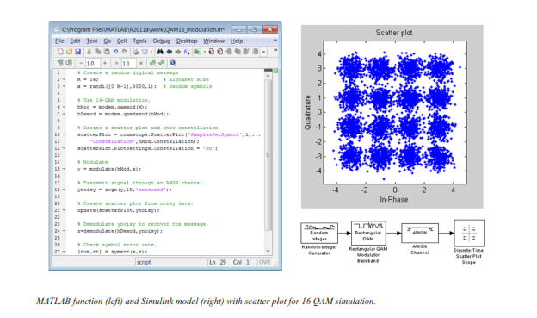**Source and Channel Coding**

Communications System Toolbox affords source and channel coding talents that can help you develop and compare communications architectures fast, enabling you to discover what-if eventualities and avoid the need to create coding competencies from scratch.

**Source Coding**

Source coding, also referred to as quantization or signal formatting, is a manner of processing facts a good way to lessen redundancy or prepare it for later processing. The system toolbox offers a diffusion of styles of algorithms for imposing source coding and interpreting, inclusive of:

▪ Quantizing

▪ Companding (*µ*-law and A-law)

▪ Differential pulse code modulation (DPCM)

▪ Huffman coding

▪ Arithmetic coding

**Channel Coding**

▪ orthogonal area-time block code (OSTBC) (encoder and decoder for MIMO channels)

▪ Turbo encoder and decoder examples

The gadget toolbox offers application functions for developing your personal channel coding. You can create generator polynomials and coefficients and syndrome deciphering tables, in addition to product parity-take a look at and generator matrices.

The system toolbox additionally presents block and convolutional interleaving and deinters leaving functions to reduce facts errors as a result of burst mistakes in a conversation machine:

**Block,** including General block interleaver, algebraic interleaver, helical scan interleaver, matrix interleaver, and random interleaver.

**Convolutional,** including General multiplexed interleaver, convolutional interleaver, and helical interleaver

**Channel Modeling and RF Impairments**

Channel Modeling

Communications System Toolbox provides algorithms and tools for modeling noise, fading, interference, and different distortions which might be commonly found in communications channels. The system toolbox supports the subsequent styles of channels:

▪ Additive white Gaussian noise (AWGN)

▪ Multiple-enter multiple-output (MIMO) fading

▪ Single-enter single-output (SISO), Rayleigh, and Rician fading

▪ Binary symmetric

A MATLAB channel object provides a concise, configurable implementation of channel models, enabling you to

specify parameters such as:

▪ Path delays

▪ Average path gains

▪ Maximum Doppler shifts

▪ K-Factor for Rician fading channels

▪ Doppler spectrum parameters

For MIMO systems, the MATLAB MIMO channel object expands these parameters to also include:

▪ Number of transmit antennas (up to 8)

▪ Number of receive antennas (up to 8)

▪ Transmit correlation matrix

▪ Receive correlation matrix

To combat the effects noise and channel corruption, the system toolbox provides block and convolutional coding and decoding techniques to implement error detection and correction. For simple error detection with no inherent correction, a cyclic redundancy check capability is also available. Channel coding capabilities provided by the system toolbox include:

▪ BCH encoder and decoder

▪ Reed-Solomon encoder and decoder

▪ LDPC encoder and decoder

▪ Convolutional encoder and Viterbi decoder

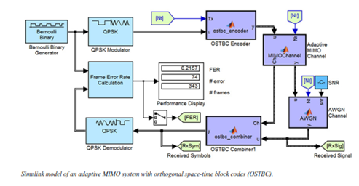

**RF Impairments**

To model the effects of a non-ideal RF front end, you can introduce the following impairments into your communications system, enabling you to explore and characterize performance with real-world effects:

▪ Memory less nonlinearity

▪ Phase and frequency offset

▪ Phase noise

▪ Thermal noise

You can include more complex RF impairments and RF circuit models in your design using SimRF™.

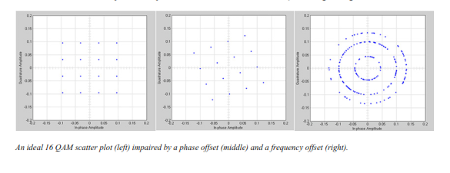

**Equalization and Synchronization**

Communications System Toolbox lets you discover equalization and synchronization strategies. These techniques are usually adaptive in nature and tough to design and symbolize. The machine toolbox affords algorithms and tools that will let you swiftly select the proper approach on your communications machine. Equalization To compare one-of-a-kind techniques to equalization, the device toolbox offers you with adaptive algorithms which include:

▪ LMS

▪ Normalized LMS

▪ Variable step LMS

▪ Signed LMS

▪ MLSE (Viterbi)

▪ RLS

▪ CMA

These adaptive equalizers are available as nonlinear decision feedback equalizer (DFE) implementations and as

Linear (symbol or fractionally spaced) equalizer implementations.

**Synchronization**

The device toolbox provides algorithms for each service segment synchronization and timing phase synchronization. For timing section synchronization, the machine toolbox presents a MATLAB Timing Phase Synchronizer object that offers the following implementation techniques:

▪ Early-late gate timing method

▪ Gardner’s method

▪ Fourth-order nonlinearity method

**Stream Processing in MATLAB and Simulink**

Most verbal exchange structures cope with streaming and frame-primarily based statistics using a aggregate of temporal processing and simultaneous multi frequency and multichannel processing. This form of streaming multidimensional processing can be visible in superior communication architectures consisting of OFDM and MIMO. Communications System Toolbox enables the simulation of advanced communications structures via helping move processing and frame-based simulation in MATLAB and Simulink. In MATLAB, circulate processing is enabled by way of System items™, which use MATLAB objects to symbolize time-based and facts-driven algorithms, sources, and sinks. System objects implicitly manipulate many information of flow processing, including information indexing, buffering, and management of set of rules state. You can mix System gadgets with fashionable MATLAB functions and operators. Most System items have a corresponding Simulink block with the identical abilities. Simulink handles circulation processing implicitly with the aid of coping with the float of information thru the blocks that make up a Simulink model. Simulink is an interactive graphical environment for modeling and simulating dynamic systems that uses hierarchical diagrams to symbolize a machine version. It includes a library of widespread-reason, predefined blocks to represent algorithms, resources, sinks, and device hierarchy.

**Implementing a Communications System**

Fixed-Point Modeling Many communications systems use hardware that requires a fixed-point representation of your design.

Communications System Toolbox supports fixed-point modeling in all relevant blocks and System objects™ with tools that help you configure fixed-point attributes.

Fixed-point support in the system toolbox includes:

▪ Word sizes from 1 to 128 bits

▪ Arbitrary binary-point placement

▪ Overflow handling methods (wrap or saturation)

▪ Rounding methods: ceiling, convergent, floor, nearest, round, simplest, and zero

Fixed-Point Tool in Simulink Fixed Point™ facilitates the conversion of floating-point data types to fixed point. For configuration of fixed-point properties, the tool tracks overflows and maxima and minima.

**Code Generation**

Once you've got advanced your set of rules or communications device, you can robotically generate C code from it for verification, rapid prototyping, and implementation. Most System gadgets, functions, and blocks in Communications System Toolbox can generate ANSI/ISO C code the use of MATLAB Coder™, Simulink Coder™, or Embedded Coder™. A subset of System gadgets and Simulink blocks also can generate HDL code. To leverage present highbrow belongings, you can choose optimizations for specific processor architectures and integrate legacy C code with the generated code.

You can also generate C code for both floating-point and fixed-point data types.

DSP Proto typing DSPs are used in communication system implementation for verification, rapid prototyping, or final hardware implementation. Using the processor-in-the-loop (PIL) simulation capability found in Embedded Coder, you can verify generated source code and compiled code by running your algorithm’s implementation code on a target processor. FPGA Prototyping

FPGAs are used in communication systems for implementing high-speed signal processing algorithms. Using the FPGA-in-the-loop (FIL) capability found in HDL Verifier™, you can test RTL code in real hardware for any existing HDL code, either manually written or automatically generated HDL code.

**CHAPTER -8**

**HARDWARE & SOFTWARE REQUIREMENTS:**

**Software:**

• Matlab R2018a.

**Hardware:**

**Operating Systems:**

• Windows 10

• Windows 7 Service Pack 1

• Windows Server 2019

• Windows Server 2016

**Processors:**

Minimum: Any Intel or AMD x86-64 processor

Recommended: Any Intel or AMD x86-64 processor with four logical cores and AVX2 instruction set support

**Disk:**

Minimum: 2.9 GB of HDD space for MATLAB only, 5-8 GB for a typical installation

Recommended: An SSD is recommended a full installation of all Math Works products may take up to 29 GB of disk space

**RAM:**

Minimum: 4 GB

Recommended: 8

**CHAPTER-9**

**RESULTS**

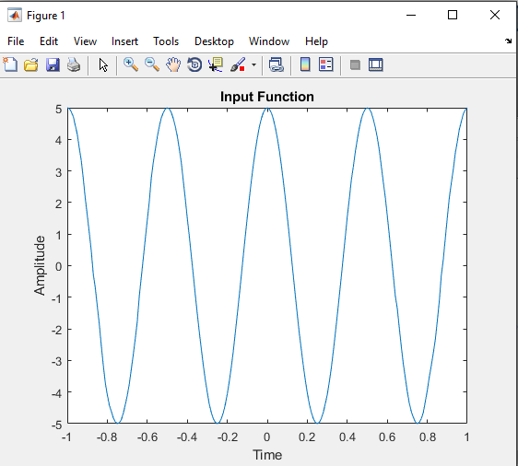

Figure:Input Function

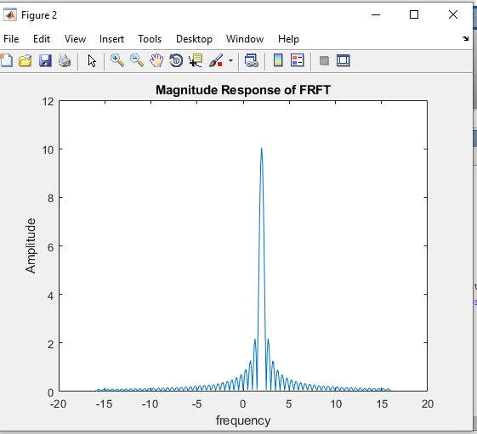

Figure: Magnitude Response of FRFT

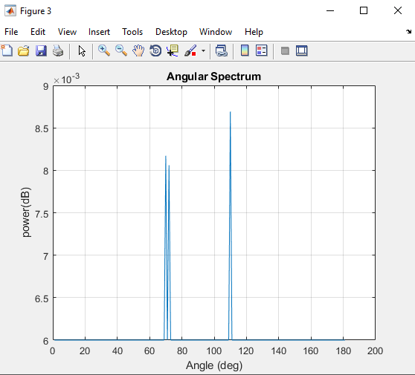

Figure:Angular Spectrum

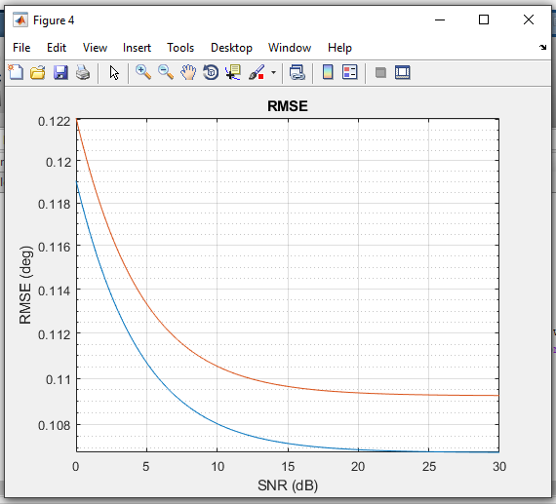

Figure:RMSE

**CHAPTER-10**

**CONCLUSION**

We presented a FrFT-MSPICE method for the DOA estimation of wideband LFM signal. We extend the SPICE algorithm in FrFT domain so that the DOA of wideband LFM signals can be estimated with a few snapshots. The proposed method has high angular resolution and low sidelobe levels. We also utilize the energy centrobaric modification method in order to increase the accuracy of the SPICE algorithm without imposing too much additional computational burden. The simulation results have demonstrated the effectiveness of the proposed method.

**CHAPTER-11**

**REFERENCES**

1. Z Li, K Liu, Y Zhao et al., MaPIT: An enhanced pending interest table for NDN with mapping bloom filter. IEEE Commun. Lett. 18(11), 1915–1918 (2011)

2. Z Li, Y Chen, H Shi et al., NDFB-GSM-R: a novel high-speed railway communication system via named data networking. EURASIP J. Wirel.Commun. Netw. 48, 1–5 (2016)

3. X Liu, Z Li, P Yang et al., Information-centric mobile ad hoc networks and content routing: a survey. Ad Hoc Netw. (2016). http://dx.doi.org/10.1016/j.adhoc.2016.04.005

4. Z Li, L Song, H Shi et al., Approaching the capacity of k-user MIMO interference channel with interference counteraction scheme. Ad Hoc Netw.(2016). http://dx.doi.org/10.1016/j.adhoc.2016.02.009

5. T Yardibi, J Li, P Stoica, M Xue, Source localization and sensing: a nonparametric iterative adaptive approach based on weighted leastsquares. IEEE Trans. Aerosp. Electron. Syst. 46(1), 425–443 (2010)

6. F Ye, Y Li, S Yang, 2-D DOA estimation of LFM signal based on FRFT, in Proc. 1st ISSCAA (Harbin, China, 2006), pp. 1080–1083

7. P Luo, K Liu, W Shi, G Yan, 2-D DOA estimation of wideband LFM signals forarbitrary planar array. in Proc. 10th ICSP, 2010, pp. 307–310

8. N Ma, JT Goh, Ambiguity-function-based techniques to estimate DOA of broadband chirp signals. IEEE Trans. Signal Process. 54(5), 1826–1839 (2006)

9. P Stoica, P Babu, J Li, New method of sparse parameter estimation in separable models and its use for spectral analysis of irregularly sampled data. IEEE Trans. Signal Process. 59(1), 35–46 (2011)

10. Z Chen, J Li, P Stoica, KW Lo, Iterative adaptive approach for wide-band active sonar array processing. in Proc. IEEE OCEANS (Sydney, 2010), pp. 1–10

11. C Zheng, K Ding, Z Yang, Noise influence on frequency estimation accuracy from energy centrobaric correction method for discrete spectrum. in Proc. ICIA’09, 2009, pp. 1477–1481

12. R Tao, F Zhang, Y Wang, Research progress on discretization of fractional Fourier transform. Science in China Series F: Information Sciences 51(7), 859–880 (2008)

13. MF Erden, MA Kutay, HM Ozaktas, Repeated filtering in consecutive fractional Fourier domains and its application to signal restoration. IEEE Trans. Signal Process. 47(5), 1458–1462 (1999)

14. HM Ozaktas, O Arikan, MA Kutay et al., Digital computation of the fractional Fourier transform. IEEE Trans. Signal Process. 44(9), 2141–2150 (1996)

15. JD Scargle, Studies in astronomical time series analysis. II. Statistical aspects ofspectral analysis of unevenly spaced data. Astrophys. J. 263, 835–853 (1982)